**Experiment No.7**

**Title:** Implementation of Bubble Sort

**Problem Statement:**

Write a C++ program to arrange the given setof numbers in ascending order using Bubble sort.

**Algorithm:**

**Step 1**

Initialize an array of required size and enter the array elements.

**Step 2**

Starting with the first element(index = 0), compare the current element with the next element of the array.

**Step 3**

If the current element is greater than the next element of the array, swap them.

**Step 4**

If the current element is less than the next element, move to the next element. **Repeat step 1.**

**Code:**

// Bubble Sort

// To sort given elements in Ascending order

#include<iostream>

using namespace std;

int main(){

int array[50], n, i, j, k, temp;

cout<<"Enter the size of array: ";

cin>>n;

cout<<"Enter the array elements to be sorted:";

//To read the array

for(i=0;i<n;++i)

cin>>array[i];

cout<<"Array before sorting :";

for(i=0;i<n;++i)

cout<<" "<<array[i];

for(i=1;i<n;++i) // i keeps track of the no. of passes

{

{

for(j=0;j<(n-i);++j)

if(array[j]>array[j+1])

{

temp=array[j];

array[j]=array[j+1];

array[j+1]=temp;

}

}

//To print the array elements after every pass

cout<<"\n\n Array after Pass "<<i<<":" ;

for(k=0;k<n;++k)

cout<<" "<<array[k];

}

cout<<"\n\nArray after bubble sort:";

for(i=0;i<n;++i)

cout<<" "<<array[i];

return 0;

}

**Results:**

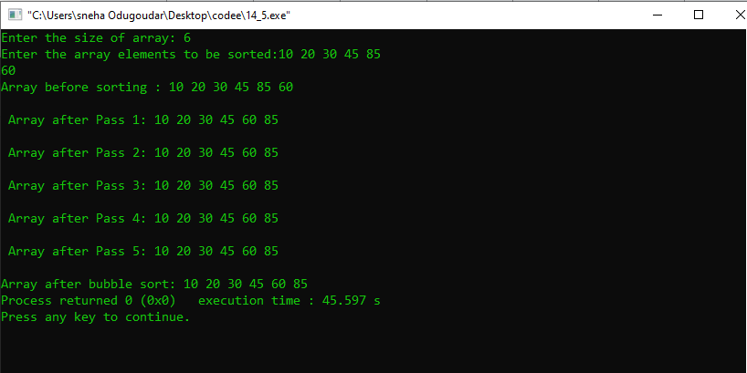

**Analysis(Limitations):**

The main disadvantage of the bubble sort is the fact that it does not deal well with a list containing a huge number of items. This is because the bubble sort requires n-squared processing steps for every n number of elements to be sorted. As such, the bubble sort is mostly suitable for academic teaching but not for real-life applications.